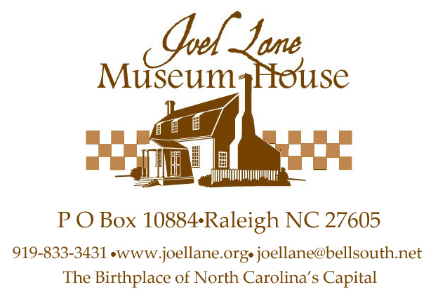

Yes, I’d like to purchase tickets to Elliot Engel’s performance
The Vanderbilts: All of Them
on Friday, February 15, 2013 at 7:00 pm at
Long View Center, 118 South Person Street, Raleigh NC 27601
Name _______________________________________________
Address _____________________________________________
City, State, Zip _______________________________________
Phone _______________________________________________
Email ________________________________________________

___Number of tickets @ $25 $____________
I’d like to make an additional donation of $____________
Total enclosed $____________
I would like to pay by _____Check or ______MasterCard or Visa

Please list all digits from your credit card

Expiration Date Security code from back of card

Signature___________________________________________

Mail to: Joel Lane Museum House
P O Box 10884
Raleigh NC 27605
Fax to: 919-833-9431
Email to: joellane@bellsouth.net
Questions? Phone the office at 919-833-3431 or email joellane@bellsouth.net.
Tickets will be held for you at will call at the door.

Financial information about this organization and a copy of its license are available from
the State Solicitation Licensing Branch at 888-830-4989.

